DESIGN AND IMPLEMENTATION OF A DIAGNOSIS SYSTEM FOR PELVIC INFLAMMATORY DISEASE USING ARTIFICIAL NEURAL NETWORK

BY

DERE, BOLUWATIFE ADESOLA
2012/1/41415CI

PROJECT SUBMITTED TO THE DEPARTMENT OF INFORMATION AND MEDIA TECHNOLOGY, SCHOOL OF INFORMATION AND COMMUNICATION TECHNOLOGY, FEDERAL UNIVERSITY OF TECHNOLOGY, MINNA, NIGERIA IN PARTIAL FULFILLMENT OF THE REQUIREMENT FOR THE AWARD OF THE DEGREE OF BACHELOR OF TECHNOLOGY IN INFORMATION AND MEDIA TECHNOLOGY (IT OPTION)

NOVEMBER, 2017

DEDICATION
This project is dedicated to the holy Trinity. God the Father, who is my Creator. God the Son, who is my Redeemer and God the Holy Spirit, who is my Teacher.

DECLARATION
I hereby declare that this project titled: Design and Implementation of a Diagnosis System for Pelvic Inflammatory Disease is a collection of my original project work and it has not been presented for any other qualification anywhere. Information from other sources (published or unpublished) has been duly acknowledged.

DERE, Boluwatife Adesola
2012/1/41415CI Signature and Date
Federal University of Technology,
Minna, Nigeria.

CERTIFICATION
The project tiled: “Design and implementation of a diagnosis system for Pelvic Inflammatory Disease using Artificial Neural Network” by: DERE Boluwatife Adesola (2012/1/41415CI) meets the regulations governing the award of the degree of Bachelor of Technology of the Federal University of Technology, Minna and it is approved for its contribution to scientific knowledge and literary presentation.

Mr. Hussain A. Zubairu
Project Supervisor Signature and Date

Professor Nicholas S. Iwokwagh
Head of Department Signature and Date

Dr. Terhemen Aboiyar
External Examiner Signature and Date

ACKNOWLEDGEMENT
My profound gratitude goes to the Almighty God who preserved me before, during and till the end of my undergraduate programme.
I want to specially thank my supervisor, Mr. Hussain A. Zubairu who gave his time and thoroughly guided me through this project work. I wish to express my utmost gratitude and appreciation to him for his scholarly supervision, assistance, support throughout my project work.
I want to express my gratitude to the Head of Department Professor Nicholas S. Iwokwagh and all other Lecturers in the Department.
My profound gratitude also goes to Pastor David Ojeishekoba, Rev. B.M. Owojaiye and Pastor Jolayemi for their prayers and encouragement, I am grateful.
I want to appreciate the family of Mr. & Deaconess John Yakubu for their prayers, parental advice, God bless you.
I appreciate the concern of my parents Mr. & Mrs. S.O. Dere for their moral training, proper upbringing, prayers, love and support. I also appreciate my wonderful siblings, Olafimihan Oyindamola, Bello Oluwakemi, Dere Oladoyin, Bello Ibidunmola and my cousin Aboyeji Folawe. I also want to appreciate Yakubu Victor, Abdulrasheed Adetoro, Omodara Mudirat, Ajeigbe Sherifat, Animashaun Mutiu, Alimi Yetunde, Obaro Rosemary, and those that I might not have mentioned, I love you all.

ABSTRACT
Pelvic Inflammatory Disease (PID) is a reproductive health infective disease of feminine genital tract and high among minority adolescent girls and young adult women. This project design and develop an artificial neural network (ANN) based diagnosis system for PID using clinical data to predict the status of patient. The ANN model was trained with 259 clinical data as input to the neural network. The system can predict the presence or absent of PID based on the available symptoms. The system recorded an accuracy of 96.1% based on the confusion matrix. The obtain result is promising, an indication that the system can be effective in diagnosis of PID cases.

TABLE OF CONTENTS

DEDICATION ii
DECLARATION………………………………………………………………………........iii
CERTIFICATION iv
ACKNOWLEDGEMENT v
ABSTRACT vi
TABLE OF CONTENTS vii
LIST OF FIGURES ix
LIST OF TABLES x
CHAPTER ONE 1
INTRODUCTION 1
1.1 Background of the study 1
1.2 Problem Statement 3
1.3 Aim and Objectives 4
1.4 Scope and Limitation of the project 5
1.5 Significance of the study 5
1.6 Operational definition of terms 5
CHAPTER TWO 6
LITERATURE REVIEW 6
2.1 Introduction 6
2.2 Pelvic Inflammatory Disease 6
2.2.1 Risk Factors for Pelvic Inflammatory Disease 6
2.2.2 Symptoms of Pelvic Inflammatory Disease 7
2.2.3 Long-Term Complications of Pelvic Inflammatory Disease 7
2.3 Overview of ANN in Medicine 8
2.4 Medicine and Machine learning 9
2.5 Artificial Neural Networks 9
2.6 Structure of Artificial Neural Networks 11
2.7 Artificial Neural Network learning 13
2.8 Neural Networks in Healthcare 16
2.8.1 Cardiovascular diseases 16
2.8.2 Cancer 17
2.8.3 Diabetes 17
2.9 ANN Related Work 18
CHAPTER THREE 21
RESEARCH METHODOLOGY 21
3.1. Introduction 21
3.2 ANN-based Medical Diagnosis flow 21
3.2.1 Feature Selection 22
3.2.2 Building the database 23
3.2.2.1 Data Collection 23
3.2.2.2 Data Transformation 24
3.2.2.3 Data Transformation 26
3.3 Data cleaning and pre-processing 27
3.4 ANN Training and verification 28
3.4.1. Training 28
3.4.2 Verification 28
3.5 System Architecture 29
3.5 Use Case Diagram 29
3.7 System in Flow Chart 30
3.8 System Requirement 31
3.8.1 Programming language 31
CHAPTER FOUR 32
SYSTEM IMPLEMENTATION AND EVALUATION 32
4.1 Introduction 32
4.2 Building the database 32
4.3 Training the Network 34
4.3 Graphical user interfaces 39
CHAPTER FIVE 46
SUMMARY, CONCLUSION AND RECOMMENDATION. 46
5.1 Summary 46
5.3Conclusion 46
5.3 Recommendation 47
REFERENCES 48
APPENDIX

LIST OF FIGURES
Figure 2.1: The biological neuron 10
Figure 2.2: Multilayer Neural Network 12
Figure 2.3: Input and Output in an ANNs-based diagnosis system biology 13
Figure 2.4: Sample structure of training database structure 14
Figure 3.1: ANN-based diagnostic flow chart 21
Figure 3.2: Schematic diagram of ANN model 24
Figure 3.3: Data transformation Matrix…………………………………………… .…25
Figure 3.4: The system architecture 29
Figure 3.5: Use case diagram 30
Figure 3.6: ANN-based PID diagnosis flow chart 30
Figure 4.1 PID datasets 32
Fig.4.2 The transformation code 33
Fig 4.3 Transformed dataset 34
Fig 4.4 Neural Network start page 35
Fig 4.5 Data selection window 35
Fig.4.6 Validation and test selection window 36
Fig.4.7 neural network structure 37
Fig.4.8: Confusion Matrix 38
Figure.4.9: The Index Page 39
Fig.4.10: Home Page 40
Fig 4.11: Symptoms selection page 41
Figure 4.12: Symptoms selection page with particular selected symptoms 41
Figure 4.13: Patient’s status of symptoms 42
Fig 4.14: Patient’s data corresponding with output 42
Figure 4.15: Symptoms selection page for negative response 43
Fig 4.16: Patient’s status of symptoms 43
Fig 4.17: Interface with no symptoms selected 44
Figure 4.18 No symptoms selected 44
Figure 4.19 Interface with some symptoms selected 45
Figure 4.20 No symptoms selected 45

LIST OF TABLES
Table 3.1: Sample training database…………………………………………………………..27

CHAPTER ONE
INTRODUCTION
1.1 Background of the study
Pelvic inflammatory disease (PID) is a reproductive health infective and syndrome of the feminine genital tract, such as the uterus, fallopian tubes, ovaries, cervix, and the Endometrium which are the pelvic structures (Dayal, Singh, Chaturvedi, Krishna & Gupta, 2016). The rate of the disease remains high among minority adolescent girls and young adult women (Dayal, Singh, Chaturvedi, Krishna & Gupta, 2016). They further stressed that the disease has become a silent killer that devastates women's life.
Ahmad (2009) posited that about 1 million (1, 000, 000) women experience an acute Pelvic Inflammatory Diseases (PID) annually and the rate is higher in younger generation and first time mothers. Ahmad (2009) maintained that above one hundred thousand women are rendered infertile annually because of PID infection, and a good number of ectopic pregnancies cases are cause by PID. He further stressed that above 150 women die from PID or its related complications. According to medical expert, if PID is not treated, it can cause sterility, ectopic pregnancy, sore development, and prolonged pelvic discomfort.
Westrom (1995) recommends shifted from inpatient to the outpatient settings in response to treatment for PID. Inpatient treatment for PID is expensive without corresponding increment in effectiveness compared with outpatient treatment, therefore (Trent, Ellen & Frick, 2011) cited cost-effective outpatient PID care supports as necessary to improve reproductive health outcomes for women (Goyal, Hersh, Luan, Localio, Trent & Zaoutis, 2013).
The diagnosis of acute PID is mostly created on historical and medical discoveries. Medical expressions of PID differ generally, though; A lot of patients show little or no symptoms, however others have acute, or severe complaint. The greatest common existing complaint is lower abdominal discomfort. The differential finding includes appendicitis, cervicitis, urinary tract infection, endometriosis, and adnexal tumors (Schindlbeck, Dziura & Mylonas, 2014). Ectopic pregnancy can be mistaken for PID; definitely, PID is mostly mistaken in cases of ectopic pregnancy (Gerberding, 2004).
The incidence of PID in developing countries is hard to assess due to poor availability of data, however cases of PID is on the rise in developing nations (Dayal, Singh, Chaturvedi, Krishna & Gupta, 2016). Therefore, this project is geared toward application of Artificial Neural Network (ANN) to predict the cases of PID occurrences.
Artificial Neural Network (ANN) is extensively applied in science and technology with applications in various areas of chemistry, physics, and biology (Amato, López, Peña-Méndez, Vaňhara, Hampl & Havel, 2013). It is a soft computing technique, that has been applied successfully in different fields of science, specifically in pattern recognition, fault diagnosis, forecasting and prediction (Chen, Hsieh & Hung Do, 2014). ANN has successfully been employed for pattern recognition and survival prediction in several clinical settings (Baxt, 1995). The advantage of ANN lies in its ability to capture nonlinearities and complex interactions between several factors. Trained on a number of predictive factors, neural networks have been considered to improve the accuracy of survival prediction for patients with lung and colorectal cancer (Jefferson, Pendleton & Lucas, 1997).
ANN is a computer program that mimics biological neurons and the network can become conversant at discovering clusters. Computer Aided Decision making in medicine can enhance and improve the consistency of care (Shanthi, Sahoo & Saravanan, 2010). The rational of computer aided decision application in medicine is to build systems that can assist human expert in the area of performance, flexibility, reliability, adequate response time, and timely response. It has the potential to cover rare conditions, because it is not possible for clinical expert to possess the compendium of all of the indices of diseases. Furthermore, computerized systems are becoming vital tools for making lives easier and with digitization of patient information that is readily available in electronic form; it is possible to compute with certain degree of accuracy clinical indices, like the possibility of diagnosis or the clinical outcome. (Shanthi, Sahoo & Saravanan, 2010), reported that computer-assisted diagnoses in medicine outperform specialists. Similarly, (Tanzila, Saleh & Amjad, 2012), asserts that medical diagnosis requires the use of computer programs as they help in supporting clinical decisions. The benefit of using computer aided decision making in medical field has resulted in human support and costs to decrease and as well led to increased diagnostic accuracy (Mahesh & Manjula, 2013). Computer aided decision making in the domain of medicine can assist computer scientists to develop and test hypothesis.
Therefore, this project proposes an ANN based diagnosis system for PID using backward propagation.
1.2 Problem Statement
Most live threatening diseases are prevalent in developing countries; especially in sub-Sahara Africa and most are preventable (WHO, 2010). India, China, Brazil, Bangladesh and Nigeria, has been identified as African countries that is dangerous for woman with life threatening disease to be (Vanguard, 2013).
Most developing nations face shortages of health workers who can accurately read and interpret diagnostic results of some life threatening diseases (Anorlu, 2008), which is the best, easiest and most cost effective way to prevent the disease, therefore, there is need for computer diagnosis systems. Nigeria, in addition to her problem of internal security, is facing the problem of shortage of health workers (Health Special Report, 2015).
The diagnosis of acute PID is primarily based on historical and clinical findings. However, clinical manifestations of PID differ; while many patients exhibit few or no symptoms, others exhibit acute serious illness, such as lower abdominal pain and cases of vaginal discharge (Shepherd, 2017). The author stressed that ectopic pregnancy can be mistaken for PID. By implication, PID can be incorrectly diagnosed in cases of ectopic pregnancy.
In order to avoid these anomalies, there is need for a system that can assist health experts in diagnostic process to prevent misdiagnosis and to save resources. The crucial role of good health, demand for an automated PID diagnosis system that is fast and reliable. Such system would address the issue of inadequate health workers in Nigeria, where few Doctors would have to attend to patients in their hundreds. This is the main focus of this project.
1.3 Aim and Objectives
The aim of this project is to design and implement a PID diagnosis system using Artificial Neural Network (ANN). This aim will be achieved through the following specific objectives;
- To design and develop a PID diagnosis system using ANN
- To implement the designed system using MatLab programming language.
- To evaluate the diagnosis accuracy of the system using some clinical data.
1.4 Scope and Limitation of the project
This project is aim to predict cases of PID using ANN based on some common symptoms of the disease. The implemented prototype in this project is capable of determine case of acute, early stage or absence of PID base on the user’s input symptom. A case of absence of symptoms is beyond the scope of this project.
1.5 Significance of the study
The developed system would mitigate the cases of misdiagnosis examination in the case of PID. With this system in place, medical diagnosis system can be readily available and accessible to many. The system has the potentials to reduce drastically the queue currently experience in major hospital because patients to doctor ratio is unproportioned.
The system will provide easy access to medical diagnosis services in the area of PID with good usability and easy to use and navigate user interface. The Government will benefit from this project, because it is far easy to implement the system than hire a medical expert. The medical personal would find it useful because it would reduce fatigue and other negative factors.

1.6 Operational definition of terms
Diagnosis: is referred to as a medical deduction or inferences about the existence of disease (PID) in the context of this project.
System : A computer program that is designed to mimic a clinical experts.
Artificial Neural Network (ANN): A computer simulated of biological neural that can be use in decision making process.

CHAPTER TWO
LITERATURE REVIEW
2.1 Introduction
Literature review is an important component of academic research. It gives background, related studies and concept about the area of study. This section gives information about relevant concept, terms and related studies on which the current study is based on. This chapter would briefly discuss pelvic Inflammatory Disease (PID), Artificial Neural Network (ANN) and its application in medical field in this section.
2.2 Pelvic Inflammatory Disease
Pelvic inflammatory disease (PID) is an infectious disease of reproductive organs in women. The abdominal region of pelvic comprises of fallopian tubes, ovaries, cervix, endometrium and the uterus. Report by United State Department of Health and Human Services, documented that the PID cases are common and affects about 1 million women each year in the United States (Higuera, 2015).
PID occurrence usually starts as bacteria that enter the vagina and make the region to become affected. As time passes, the infection moves unto the pelvic organs. PID can become very alarming, even life-threatening, if the infection gets to the blood stream (Higuera, 2015).
2.2.1 Risk Factors for Pelvic Inflammatory Disease
Though one can develop Pelvic Inflammatory Disease even without traces of sexually Transmitted Infection (STI), the disease could be aggravated if patient has gonorrhoea or chlamydia. Some of the risk factors are:
- Starting of sexual experience at a tender age
- Having multiple sex partners with more than one person
- Engaging in an unprotected sex
- The use of intrauterine device (IUD) as pregnancy control measure
- Family history of pelvic inflammatory disease
- Douching often
2.2.2 Symptoms of Pelvic Inflammatory Disease
Pelvic Inflammatory Disease varies among the patients. While some women have symptoms others do not show any symptoms. However, for those that have symptoms, it could include these among others;
- Low Abdominal pain
- Feverish condition
- Painful sexual experience
- Painful urination
- Irregular Bleeding
- Vaginal discharge
- Fatigue
- Vomiting
- Fainting/tiredness
- Waist pain.
2.2.3 Long-Term Complications of Pelvic Inflammatory Disease
If PID is untreated, the symptoms can be worse and degenerate to the following issues:
- Infertility
- Ectopic pregnancy
- Severe pelvic pain
- Tubo-ovarian abscess
If the infection gets diffused to other parts of the body, it can become life-threatening (Higuera, 2015). Pelvic inflammatory disease is a treatable condition and most patients of PID cases make a full recovery. However, Centres for Disease Control and Prevention documented that about 10 to 15 percent of women with PID cases will experience difficulty in getting pregnant. Berkeley County Health Department also observes that about 9 percent of women will develop an ectopic pregnancy, and 18 percent of women will have chronic pelvic pain as a result of pelvic inflammatory disease.
2.3 Overview of ANN in Medicine
The domain of medical field has developed around organizing, management, storing, manipulation and transmission of medical data for different reasons (Shortliffe, Perreault, Fagan & Wiederhold, 1990). The goal has been to develop medical decision-support systems that complement the clinical expert’s ability to diagnose, treat, and assess prognoses of pathologic conditions (Shortliffe, Perreault, Fagan & Wiederhold, 1990). Inadequate knowledge of diseases and unpredictable nature of populace still hamper diagnosis, treatment, and prognosis, which are crucial for good health care. Shortliffe, Perreault, Fagan & Wiederhold (1990) asserts that it is sometimes not feasible for medical expert to use the principles learned in medical college to judge whether a patient has a given disease, or which type of treatment should be administered.
Overcoming the limit reasoning capability of human is the rationale behind decision-support system in medical field for diagnosis, prognosis, or suggestion for treatment in a particular case.
Artificial Neural Networks (ANNs) have been proved to solve complex problems with reasonable degree of accuracy and they constitute good models in medical domain. This chapter review ANN, its basic concepts, selected applications of neural networks in medicine and related ANN studies in medicine.

2.4 Medicine and Machine learning

Machine-learning approaches for classification gives alternative and cost effective means to carry out diagnosis, prognosis, or detection of certain outcomes in health care research (Ohno-Machado, 1996). Given the rate of increases in electronic medical records, the adoption of electronic clinical databases, and the increasing costs of manual processing, it is possible that machine-learning applications will be require to detect rare conditions, unnecessary procedures, and unexpected outcomes. Even though, the patterns may be infrequent, they may be typical and their detection is important. Thus, there is a need to enhance the predictive power of machine-learning methods by increasing sensitivity for low-frequency patterns without decreasing specificity (Ohno-Machado, 1996).
Machine-learning approaches could be used to develop systems that assist with the diagnoses of diseases for patients. The goal of this project is to develop an ANN based machine-learning approaches to recognize PID symptoms and thereby improve their predictive abilities. The network would be train using backpropagation.
2.5 Artificial Neural Networks

Artificial Neural Networks are machine-learning models implemented using a computational framework developed mainly to understand and simulate physiological or biological neural systems (Rumelhart, Hinton & Williams, 1986). It is a neural system characterized as an information-processing system motivated by the structure of the human cerebrum neuron. A typical biological neural is as shown in figure 2.1.
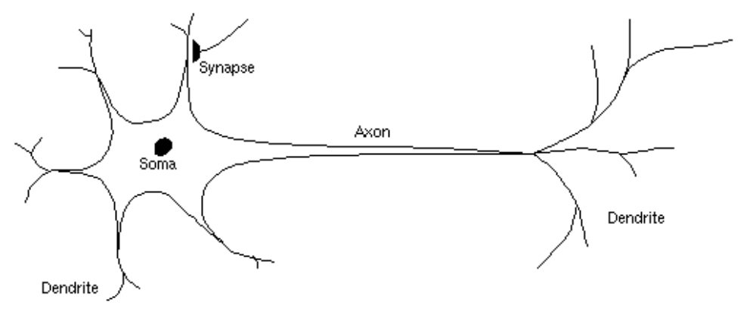
Figure 2.1: The biological neuron (Simon, 2012).
ANNs comprise of different interconnected neurons. A neuron is an information-processing unit that gets an inputs from its information sources, each of which has a weight serves to it. These weights relate to synaptic proficiency in natural neurons. Weights are the essential parameter in ANNs (Negnevitsky, 2005). Unlike, the natural neurons, the weights of the ANN are set to random numbers either by the system or the user for a set of training data sets (Andries, 2002).
Neurons learning capability depends on the particular learning algorithms adopted. The learning process entails adjustment of the weight and threshold values until specific desire criteria is achieved (Singh, Rawat, Pawar & Mishra, 2012).
ANNs are computer simulated applications having levels of computing nodes which is analogous to the human biological neurons with good information processing features. They can identify nonlinearity when formulated as inputs, given it the ability to learn and adapt. ANN have high parallelism, robustness, generalization and noise tolerance, which give it the capability to cluster, forecasting and association, and performing massively parallel multifactorial analyses for modelling complex patterns, in the absence of much information (Singh, Rawat, Pawar & Mishra, 2012).
ANN has different applications in different area of endeavour, while neuroscientists use ANN to simulate the function of real neurons, Engineers and Scientists used them to model processes, stock market prediction, speech recognition and diagnosis of medical issues (Hertz, 1991). Neural networks have been applied for different purposes in medical research. MEDLINE, a literature of medical database has more than 600 articles that describe neural networks for diagnosis, prognosis, or clustering of medical data, and applications in the basic clinical sciences.
2.6 Structure of Artificial Neural Networks

Artificial Neural Networks are normally organized in layers. Each layer in a layered network comprises of array of processing elements or neurons. Information flows through each element in an input-output fashion. That is, each element receives an input signal, manipulates it and forwards an output signal to the other connected elements in the adjacent layer. A hypothetical sample of such a network is the Multilayer Perceptron (MLP) shown in figure 2.2. MLP neural networks usually have three layers of processing elements with only one hidden layer, though there is no limit on the amount of hidden layers. The number of neurons in a layer and the number of layers is largely a function of the complexity of the system under consideration. Thus, the optimal network architecture must be first and foremost established. The role of the input layer is to receive the external stimuli (symptoms in this project) and to pass it to the next layer. The hidden layer receives the weighted sum of incoming signals sent by the input units and gets it processed by means of an activation function. The activation functions most commonly used are the saturation (Eq. 2.2), sigmoid (Eq. 2.3) and hyperbolic tangent (Eq. 2.4) functions. The hidden units in turn send an output signal towards the neurons in the next layer. This adjacent layer could be either another hidden layer of arranged processing elements or the output layer. The units in the output layer receive the weighted sum of incoming signals and process it using an activation function. Information is propagated forwards until the network produces an output.
Input layer
Output layer
Hidden layer
Information flow

Figure 2.2: Multilayer Neural Network
The input layer is comprised of patients’ information in the PID diagnostic system. The hidden layers have weights attached to them and generate output layer. That is to say, MLP propagates its input values to the output using initial data received. Backward propagation is the training algorithm used by MLP. This algorithm continuously gives the input data to the neural network. In each iteration, the output data is compared with the desired value, the detection of an error is computed and resend back (back propagated) to the network. The feedback is use to modify the weights of artificial neurons (Sivanandam, Sumathi & Deepa, 2006).
2.7 Artificial Neural Network learning

The mathematical procedure through which ANN learns can be largely overlooked by the end user. In other word, the learning process is of less important to the user(s) biology (Amato, López, Peña-Méndez, Vaňhara, Hampl & Havel, 2013). Therefore, the artificial neural network can be perceived as “black box” that receives a vector with m inputs and provides a vector with n outputs. See figure 2.3.

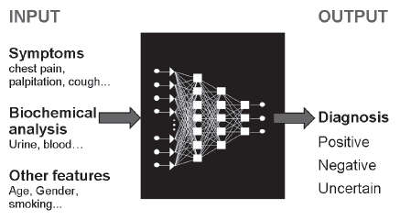

Figure 2.3: Input and Output in an ANNs-based diagnosis system biology (Amato, López, Peña-Méndez, Vaňhara, Hampl & Havel, 2013).

ANN architecture is usually hidden from the user; therefore, figure 2.3 is represented as black box. The ANN “learns” from a series of “data” that form the “training database”. The database structure has a form of table or matrix containing information about health status of patients and their diagnosis (Kajan, Pernecký & Goga, 2015). See figure 2.4.

patient ID | Medical Symptoms |  |  |  |  | Diagnosis
 | data_{1,1} | ……… | data_{1,i} | …….. | data_{1,m} | Postive
  1
2 | data_{2,1} | ……… | data_{2,i} | …….. | data_{2,m} | Postive
3 | data_{3,1} | ……… | data_{3,i} | …….. | data_{3,m} | Postive
.. | …….. | ............ | …….. | …….. | ……... | ………
K | data_{k,1} | ……… | data_{k,i} | …….. | data_{k,m} | Negative
k+1 | data_{k+1,1} | ……… | data_{k+1,i} | …….. | data_{k+1,m} | Negative
…. | ……... | ………. | …….. | …….. | ……… | ………...
N | data_{n,1} | ……… | data_{n,i} | …….. | data_{n,m} | Negative

Figure 2.4: Sample structure of training database structure

Each row refers to a different patient labelled with a numerical code. The element data_{k,i} refers to the i^{-th} medical data (in this project PID symptom; pelvic pain, painful sex, vagina discharge, etc.) of the k^{-th} patient.
For instance, a “data” is formed by a vector X_{im} = (x_{i1}, x_{i2}, …., x_{im}) of inputs and a vector Y_{in} = (y_{i1}, yi_{2,..,} y_{in}) of outputs. The objective of the training process is to approximate the function f between the vectors X_{im} and the Y_{in}. It is given by the equation;
Y_{in} = f (X_{im}) …………………………………… ……………. (2.1)
This is attained by iteratively changing the values of the connective weights (w_{ij}) according to an appropriate mathematical approach called the training algorithm. The values of the weights are changed using steepest descent method to minimize a suitable function used as the training stopping criteria. Sum-of squared residual functions is mostly used, it is given by
) ………………………………… (2.2)
where y_{ij} and y_{ij} * are the actual and network’s j^{-th} output corresponding to the i^{-th} input vector, respectively. The current weight change on a given layer is given by Eq. (2.3):
w_{ij} 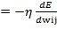) ……………………………………. ………………. (2.3)
where η is a positive constant called the learning rate. To obtain faster learning and avoid local minima, an additional term is used and Eq. 5 becomes:
w^{k}_{ij} = + w^{k-1}_{ij} ) …………………………………… (2.4)
where μ is the “momentum” term and w^{k-1}_{ij} is the change of the weight w_{ij} from the (k-1)^{-th} learning cycle. The learning degree determines the weight update rate according to the new weight change and the momentum acts as a controller, because its aware of the earlier change in weight biology (Amato, López, Peña-Méndez, Vaňhara, Hampl & Havel, 2013).

When an ANN is trained on a set of data, it builds a predictive model that reflects a minimization in error when the network's prediction (its output) is compared with a known or expected outcome biology (Amato, López, Peña-Méndez, Vaňhara, Hampl & Havel, 2013).Training, which is equivalent to biological learning process, is carried out by a researcher that feeds in the training dataset from a database and adjusts the weights and thresholds value of the network to minimize the error between the real-world outputs and the network generated outputs for the training case inputs. The network would then be cross checked with available data. Conventionally in clinical settings, expert opinions have been developed from clinicians' experience and search of the literature. Currently, ANNs and different data analysis can be used to analyse the multitude of data simultaneously and to learn trends in population, therefore expanding the "localized" knowledge to a more "global" knowledge, which can be accessed by other practitioners (Baxt, 1995).
2.8 Neural Networks in Healthcare

Neural Network is preferred to conventional programming because of its capability to solve problems that either have no algorithmic solution or the available solution is too complex to be determined. Neural networks are well suited to handle problems that humans or experts are good at solving, like prediction and pattern recognition (Aizenberg, Aizenberg & Hiltner, 2001). Neural networks have been applied within the medical domain for clinical diagnosis (Baxt, 1995), image analysis and interpretation (Miller, 1993), signal analysis and interpretation, and drug development (Weinstein, Kohn & Grever, 1992). This section would give a brief overview of application of artificial neural network in the field of diagnosis for specific diseases in healthcare.

2.8.1 Cardiovascular diseases
Cardiovascular diseases (CVDs) are diseases that mostly affect the heart, including the arteries and veins. CVDs are causes of many untimely deaths across the globe. National Centre of Health Statistics (NCHS) reported that CVD is a leading cause of death in the United States. They stressed that the diseases have become an important field of study in the last two decades.
According to available literature, many research papers about the use of ANNs in cardiovascular diseases and related topics have been published in the last nine years. ANNs have been applied in other heart related diseases, like heart valve defects (Uğuz, 2012). Heart sound recordings were obtained from 120 patients and classified as normal, pulmonary, and mitral stenosis heart valve diseases via stethoscope. Accurate categorization was achieved for 95% of the different sounds. An accuracy of about 99.8% and 99.2% respectively, was achieved by two different models developed by (Özbay, 2009) for the diagnosis of arrhythmias. Thus, ANNs can be applied to the medical diagnosis of completely different diseases different from heart related.
2.8.2 Cancer
Cancer is a becoming a major life threatening disease in the world all over. Therefore, there is need for efficient and correct diagnosis for the clinical management of cancer and cancer patients, and by extension the appropriate therapeutic measures. The application of ANNs in differentiating types of cancer types or cases of cancer prediction started in the late 1990s as a promising computational-based diagnostic tool using various inputs (El-Deredy, Ashmore, Branston, Darling & Williams, 1997). The application of neural networks trained on defined data sets was evaluated in 1994 for breast and ovarian cancer, opening a discussion on the suitability of particular data as inputs for ANN analysis. Thereafter, successive prediction of in vitro chemotherapeutic response based on glioma biopsy extracts was achieved using ANNs to obtain automatic differential diagnosis of glioma (El-Deredy, Ashmore, Branston, Darling & Williams, 1997).
In addition, evolution of analytical methods and computing capability, gives suitable information for clinically relevant of ANN. This approach has been successfully applied in the diagnosis of ovarian cancer (Thakur & Mishra, 2011). The capability of ANN for the classification of different types of lung carcinoma in real clinical or laboratory situations has been documented in many literatures and it gives increased diagnostic accuracy for various kinds of cancers (Thakur & Mishra, 2011).
2.8.3 Diabetes
Leon, Alanis, Sanchez, Ornelas-Tellez & Ruiz- Velazquez (2012), maintained that diabetes constitutes a major health challenges in developed nations, with estimated numbers reaching 366 million diabetes cases globally in 2030. According to (Leon, Alanis, Sanchez, Ornelas-Tellez & Ruiz- Velazquez, 2012), type II cases of diabetes is the most common, in which to insulin is damage because of some mineral deficient leading to disruption of tissue. The diabetes diagnosis process is through measurement of glucose level in blood specimen. Non-invasive methods based on near-infrared to monitor glucose levels were developed in 1992 (Arnold, 1996) and available as a smartphone application (Amato, López, Peña-Méndez, Vaňhara, Hampl & Havel, 2013).
The ANNs deduce glucose levels from spectral curve, therefore creating convenient monitoring of diabetes during daily activities. Quality of life itself, including satisfaction, social interactions, and depression, has been defined as an integral outcome measure in management of diabetes mellitus (Amato et al., 2013), through the application of ANN. The result from the application of ANN in the clinical setting was far better than those obtained using other approaches such as statistical or fuzzy regression methods (Amato et al., 2013).
Summarily, the use of artificial neural networks in the medical diagnosis provides an improvement in accuracy, sensitivity, and specificity in comparison with other methods, thus contributing to improved clinical management of many diseases.

2.9 ANN Related Work
There are several research works that have applied neural networks in clinical diagnosis of disease, essentially in the detection and classification of people at-risk of certain ailment (Nazeran & Behbehani, 2001). Artificial neural networks have produced satisfactory results for diagnosis of various diseases (Amato et al., 2013). ANN application and its uses make diagnosis process more reliable and increases in patient satisfaction. Nevertheless, regardless of its wide applicability in modern diagnosis, they must be considered only as a tool to facilitate the final decision of a medical experts, who is responsible for critical evaluation of the ANN output (Amato et al., 2013) asserted. ANN can be employed to streamline the diagnostic process in daily routine and avoid misdiagnosis. These adaptive learning algorithms can handle diverse types of medical data and integrate them into categorized outputs (Amato et al., 2013).
Banerjee (2003) suggested the role of the ANN, which uses non-linear statistics for pattern recognition in predicting one-year liver disease-related mortality using information available during initial clinical evaluation.
Mattias (2006) revealed that fully connected feed forward and backward propagation learning rule, were able to predict patients with colorectal cancer more accurately than clinic pathological methods. They reveal that neural network predict the patients’ survival and death very well compared to the surgeons.
Artificial neural network can provide means for improvement in the diagnosis process of early acute allograft rejection, however further development is required before it is accepted or becomes a routine diagnostic tool (Furness, Levesley, Luo, Taub, Kazi, Bates & Nicholson, 1999). The selection of cases used to train the network is very important to the quality of its performance and output. There is still possibility to improve the system further by incorporating clinical information (Furness et al., 1999).
The use of the ANN model as a data mining tool is very promising for new knowledge discovery in nephrology, to model complex behaviour of different molecular markers of dialysis treatment and for online treatment monitoring (Fernández, Valtuille, Presedo & Willshaw, 2005). The research of (Gjertsson, Lomsky, Richter, Tout, Van, Underwood & Edenbrandt, 2006), presented an automated method using ANNs were compared with the clinical interpretation.
Shanthi, Sahoo and Saravanan (2010), in their research utilize functional model of ANN to aid existing diagnosis methods. The research investigated the use of Artificial Neural Networks (ANN) in predicting the Thrombo-embolic stroke disease. The Back propagation algorithm was used to train the ANN architecture and the same has been tested for the various categories of stroke disease. This result reveals that ANN based prediction of stroke disease improves the diagnosis accuracy with higher consistency. They stressed that ANN exhibits good performance in the prediction of stroke disease in general.
From available literatures, artificial neural networks, has been applied in different areas of medical science, such as cancer, diabetes and heart related diseases diagnosis. However, as far as we are aware, not much research on diagnosis of PID disease takes advantage of ANN. Therefore, our main goal is to use the efficient training algorithm for constructing a neural network that can accurately diagnose PID.

CHAPTER THREE
RESEARCH METHODOLOGY
3.1. Introduction
Research methodology is an integral part of any scientific writing, because it provides the necessary information that allows the audience to judge the validity of the results and conclusions of the study reported. Therefore, this section explains how the propose system will be realized and the objectives achieved.
3.2 ANN-based Medical Diagnosis flow
The fundamental flow of a typical ANN medical diagnosis system based on clinical cases is shown in figure 3.1, which in this project provides the basic steps that would be followed to apply ANNs for the purposes PID diagnosis with reasonable degree of confidence.
Positive
Negative
Acute
No
Yes
Patient to be examine
ANN and Database
Diagnosis
Evaluation by Medical expert
New patient?
Stop
Yes
Start
Feature selection
Building Database using patients’ data
Pre-processing

Outlier(s)?
Verified Database
ANN training and verification
Outlier(s)
elimination
Database cleaning
No

Diagnosis phase
Training phase

Figure 3.1: ANN-based diagnostic flow
As shown in figure 3.1, building of the database and “training” represents the left half and the right represent diagnosis phase of the process.
From figure 3.1, the neuron (networks) takes symptoms as input to predict the PID status of the patient. After the disease is established, symptoms that provide the information needed to discriminate the different health conditions of the patient are carefully selected. This is done in order to eliminate features that are redundant. After that, database is build, validated and “cleaned” of outliers. When training and verification are done, the network can be put into use to predict the diagnosis of disease (PID). At the end, the predicted result is evaluated by a medical expert.
3.2.1 Feature Selection

Accurate diagnosis of any ailment is a function of available data (features): laboratory analysis, clinical evaluation, instrumental data, subjective anamnesis of the patient, and expert opinion of the clinician (Amato et al., 2013). Medical experts are trained to deduce important information from each type of data to identify possible diagnoses.
Similarly, in ANN application, such data are referred to as “features”. Features are symptoms that can assist in diagnosis process. The ability of ANN to learn from available data makes it flexible but a powerful tool to improve medical diagnosis process (Amato et al., 2013).
Since, it is not all the features that can be utilize, only those data that are necessary indicator of PID based on available record and expert opinion was selected. Features that are redundant are out rightly removed.
In any case of missing values, the data was completely removed, because such values are not suitable for neural network training.

3.2.2 Building the database
The building of the database for the system comprises of the following:
3.2.2.1 Data Collection
A total of 256 patients record treated for Pelvic Inflammatory Diseases (PID) were collected for this project. Data were obtained from three different hospitals, namely; bay clinic, optimal scan in Minna metropolis and Kwara state Advance Diagnostic Centre.
Nine predictor variables; pelvic pain, lower abdominal pain, vomiting, painful urination, painful sex, waist pain, tiredness, irregular bleeding and vagina discharge were selected to build the Artificial Neural Network model for diagnosis of PID because of their previously established influence on patient outcomes after diagnosis.
PID disease was recorded from the medical record as previously known clinical evidence of the disease confirmed by a typical history, positive, negative or acute stage. The output of the network is the patient PID status. This description is illustrated in Figure 3.2.

Input layer
Output layer
Hidden layer
Abdominal pain
Vomiting
Painful urination
Tiredness
Waist pain
Vagina discharge
Pelvic pain
Painful sex
PID status
Irregular bleeding

Figure 3.2: Schematic diagram of ANN model
Figure 3.2 is a schematic representation showing the structure of the artificial neural network model, with 9 input nodes, 5 hidden layer, and 1 output node, which represents the PID status of a patient.
3.2.2.2 Data Transformation

The data collected is transform into a suitable format for the training of the network. The transformation is a matrix of data concerning patients for whom the diagnosis (positive, negative or acute) about PID disease that is already known. Each row of the matrix refers to one patient. The first m elements of the row are medical data and the last n elements represent the output (diagnosis).
The term “medical condition” represents symptoms and other information provided by the medical specialist. Figure3.3, is the transformation of collected data.

Medical condition Diagnosis
PP LAP VD VO PU PS IB T WP PID
YES YES YES YES YES YES YES YES YES YES
YES YES NO NO YES YES NO NO NO NO
NO YES YES NO YES NO NO NO NO YES
YES YES YES YES YES YES YES YES YES YES
YES YES YES NO YES NO NO NO YES NO
NO YES YES NO YES YES NO YES YES YES
NO YES YES YES YES YES NO NO YES YES
YES YES YES YES YES YES YES YES YES YES
YES YES YES NO NO NO NO NO NO NO

Figure 3.3: Data Transformation Matrix

Key: pp-pelvic pain, LAp, low abdominal pain, Pu-painful urination, Wp-waist pain, T-tiredness, VO-vomiting, Vd- vaginal discharge, Ps- painful sex, Ib- irregular bleeding.
Each of the possible symptoms will be used to train the network. This network has one hidden layer as shown in figure 3.2 and is trained with a two-layer feedforward and back-propagation algorithm. The network will be implemented in Matlab software using the neural network toolbox component of Matlab environment. However, the data in figure 3.2 is incompatible for direct implementation in Matlab; Therefore, the data is being transformed into 0’s and 1’s as a compatible format for the Matlab. This is shown in Table 3.1

3.2.2.3 Data Transformation
Creating database for neural network training is necessary in order to describe the clinical status of the known symptoms as accurate as possible. In the cause of doing this, data which are inaccurate about the patient's diagnosis will not be used. This selection process of suitable characteristic data was carried out by the researcher in collaboration with clinical experts. The data in this context are basic health information about PID patient’s health status, results of laboratory test, sign and symptoms and other relevant information that helps ascertain the correct diagnosis process of PID. Data of one patient which were collected and feed in to the system represent one input pattern of neural network. The ability of generalization of the found dependence between symptoms and diagnosis is a direct function of the input patterns used in the training process. The database should therefore contain a sufficient amount of reliable patterns which characterize the diagnosis. This will enable the training process of the neural network to approximate the hidden dependence in the data set and to use this knowledge to generalize in patient’s diagnostic status, even for cases which are not capture in the training dataset. The database format is a form of matrix containing information about health status of patients and their diagnosis in form of 0’s and 1’s. See table 3.1.

S/n |  | Clinical data |  |  |  |  |  |  |  |  | Result
1 | 1 | 1 | 1 | 0 | 1 | 0 | 0 | 0 | 1 | 0
2 | 1 | 1 | 1 | 1 | 1 | 1 | 1 | 1 | 1 | 1
3 | 1 | 1 | 0 | 0 | 1 | 1 | 0 | 0 | 0 | 0
4 | 0 | 1 | 1 | 0 | 1 | 0 | 0 | 0 | 0 | 1
5 | 1 | 1 | 1 | 1 | 1 | 1 | 1 | 1 | 1 | 1
6 | 1 | 1 | 1 | 0 | 1 | 0 | 0 | 0 | 1 | 0
7 | 0 | 1 | 1 | 0 | 1 | 1 | 0 | 1 | 1 | 1
8 | 0 | 1 | 1 | 1 | 1 | 1 | 0 | 0 | 1 | 1
9 | 1 | 1 | 1 | 1 | 1 | 1 | 1 | 1 | 1 | 1
10 | 1 | 1 | 1 | 0 | 0 | 0 | 0 | 0 | 0 | 0

Table 3.1: Sample training database

3.3 Data cleaning and pre-processing

Fundamentally, data in the training database must be pre-processed before evaluation of the networ k takes place. As part of cleaning and pre-processing, redundant data and missing values were removed and the data is scaled to lie within the (0, 1) because of compatibility with Matlab programming environment.

3.4 ANN Training and verification
3.4.1. Training

The network must be trained using a suitable database. The database is a matrix of data concerning patients for whom the diagnosis (positive, negative or acute) about PID is already known.
Training a neural network is the process of setting the best weights on the inputs of each of the units. The goal is to use the training set to produce weights where the output of the network is as close to the desired output as possible for as many of the examples in the training set as possible.
Training and testing of neural network model for PID disease will be realized in Matlab programming environment using the neural toolbox. The sample dataset of 9 input nodes, 5 hidden layer, and 1 output node will be selected in our network structure.
A two-layer feedforward and backward propagation (Ahmed, 2005) algorithm will be adopted to train the network using the available data or features.

3.4.2 Verification

ANNs-based medical diagnosis need to be verified by means of a dataset different from that one used for training. This verification or testing of the network to access its diagnostic accuracy will be carried out in chapter four.
For each new patient data, the network’s outcome needs to be scrutinized by a medical expert. Record of patients for which the predicted diagnosis is correct can be added in the training database.

3.5 System Architecture


Architecture of any system is a logical model, structured in a way that defines the organization and behaviour of the system. That is, system architecture is a way for a formal representation of any given system. The architecture of the proposed system is shown in Figure 3.4.
User Interface
ANN inference engine
Output
User

Figure 3.4: The system architecture
From the figure above, the user will interact with the user interface by selecting the appropriate symptoms, the ANN inference engine will process the user query and an output will be displayed which will show the medical status of the patient.
3.6 System’s Use Case Diagram
Use case diagram is a software design methodology used to visually depict the user’s interaction and user’s capability or privileges with a particular system. This is shown in Figure 3.5.

Input symptoms
View result
Log out

User
Figure 3.5: Use case diagram

3.7 System in Flow Chart
Flow chart is a graphical representation of a system showing the sequential flow of operational process of any given system. The flow chart of the proposed PID diagnostic system is shown in Figure 3.6.
Stop
Start
Input symptoms
New symptom?
ANN evaluation
Output result
No
Yes

Figure 3.6: ANN-based PID diagnosis flow chart
As shown in the flow chart, the user initiates the application and supply the symptoms, the ANN inference engine evaluates the inputs and displays the result to the user. The result could be negative, positive or acute case of PID depending on the user’s inputs to the system. The system terminates if there are no inputs of new symptoms else it repeats the entire process again.
3.8 System Requirement
MatlabR2017a software was executed in windows operating system for the execution of the PID diagnostic system; however, it can also run on different operating system. The system is expected to function optimally with the minimum of the following configuration 1.00 GHz or more of processor,2.00GB RAM, and 64 bits operating system should be enough to successfully execute the application.
3.8.1 Programming language
MatlabR2017a programming environment is the proposed language for the implementation and the entire development of the proposed application. The advantage of Matlab is the inbuilt functionality for ANN training and validation. It is relatively easy to program, robust and it provides good and appealing user interface for user interaction.

CHAPTER FOUR
SYSTEM IMPLEMENTATION AND EVALUATION
4.1 Introduction
This chapter describes the implementation and evaluation process conducted on the diagnostic for pelvic inflammatory disease. The program implementation includes all the activities that was carried out in order to put the program designed into a functional state.
4.2 Building the database
The data to be use need to be in database for the training and subsequent evaluation. The database for the implementation is as shown in Figure 4.1.
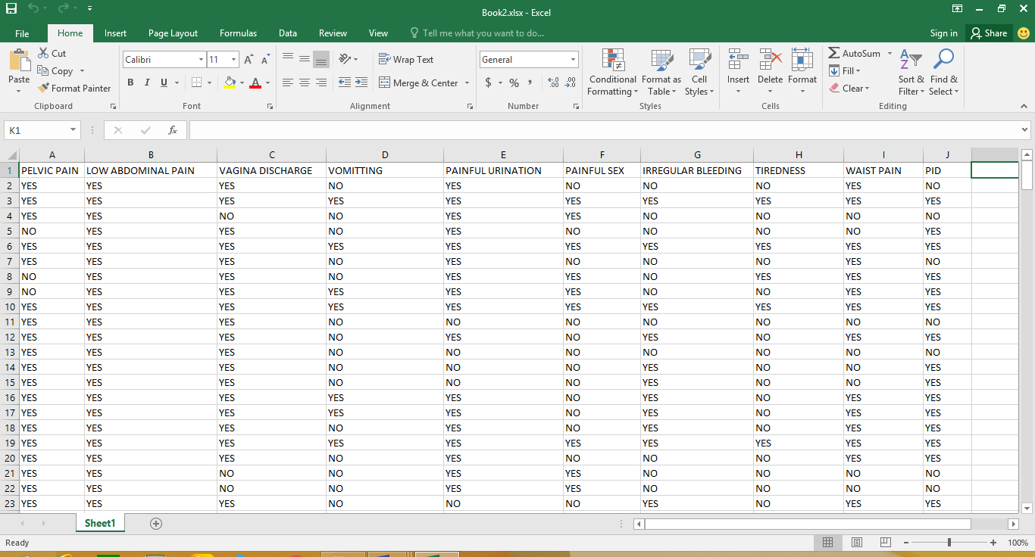
Figure 4.1: PID datasets

As shown in Figure 4.1, the data in this format is not readable by Matlab, therefore transformation is done to transform the data into 0’s and 1’s. The transformation code was implemented in Matlab environment as shown in Figure 4.2.
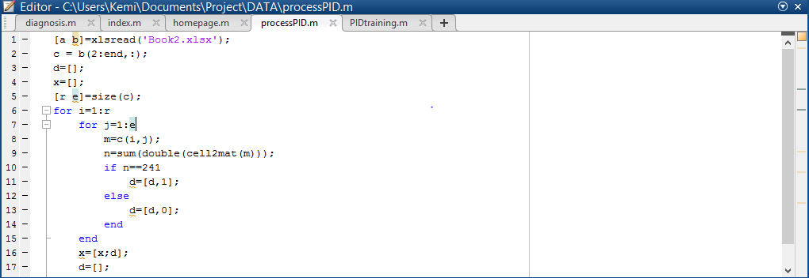
Figure 4.2: The transformation code
The result of the transformed data is as shown in Figure 4.3. This format was used for the training of the system and evaluation.

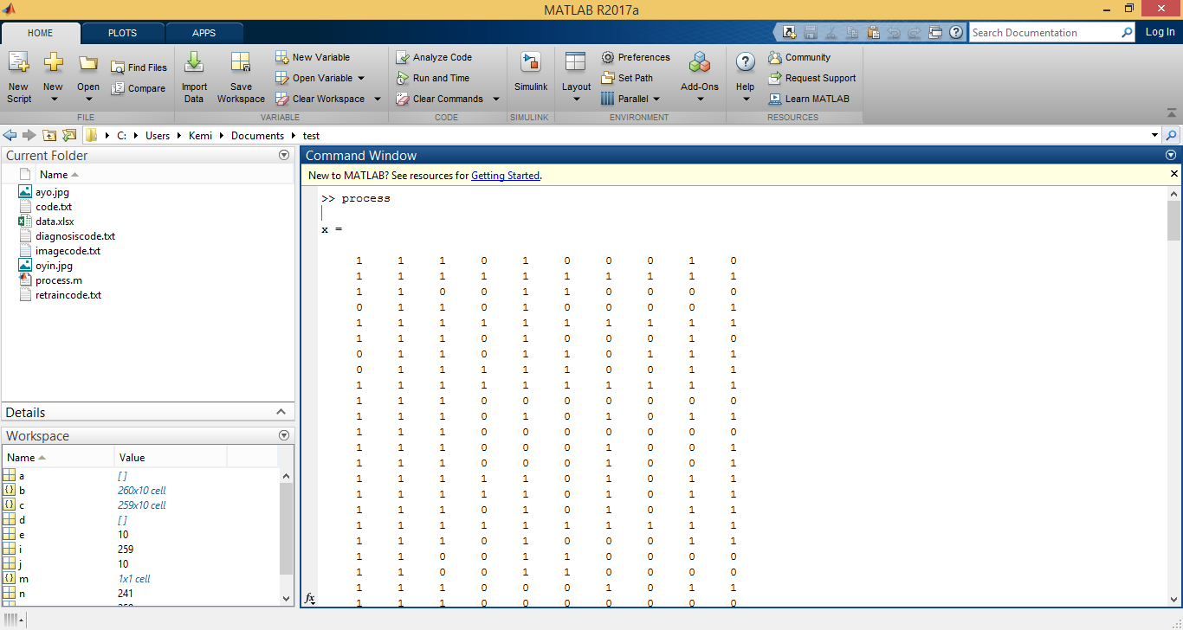Figure 4.3: Transformed dataset
4.3 Training the Network
The training phase of the network was implemented using neural toolbox in the Matlab environment. Training and evaluation parameters needed to set for the process. One-layer feedforward and backward propagation algorithm was adopted to train the network using the available data or features and Matlab inbuilt functionalities.
The necessary steps for training and evaluation are as shown in Figures 4.4 to 4.7. Figure 4.1 is the neural network start page, where pattern recognition is selected to generate the appropriate background script.
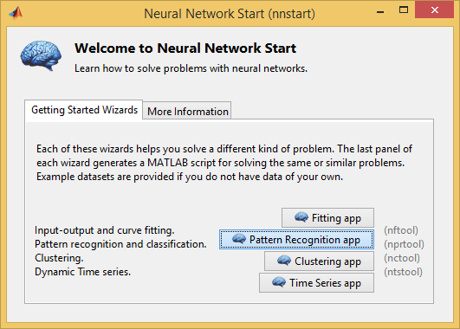
Figure 4.4: Neural Network start page
Once the datasets have been transformed and the tool for training the network has been chosen, then the input and output need to be selected. The data input is the already transformed data set that is needed for the training, the target data is the network desired output. This is illustrated in Figure 4.5.
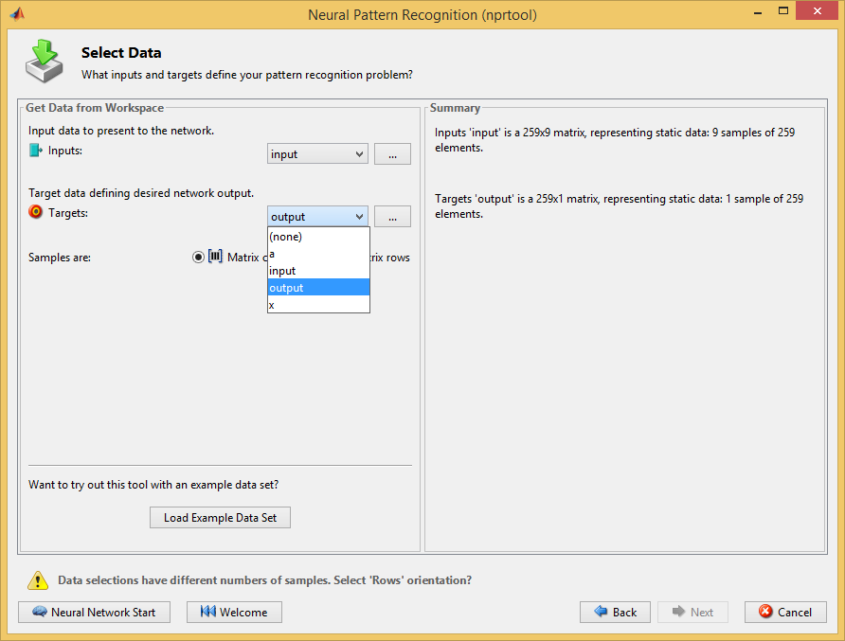
Figure 4.5: data selection window
After the selection of the target data and the output format, the percentage of the training and validation needed to be set in the Matlab wizard. As shown in Figure 4.6, 70% of the data was used for training the network, 15% for validation and 15% for testing.
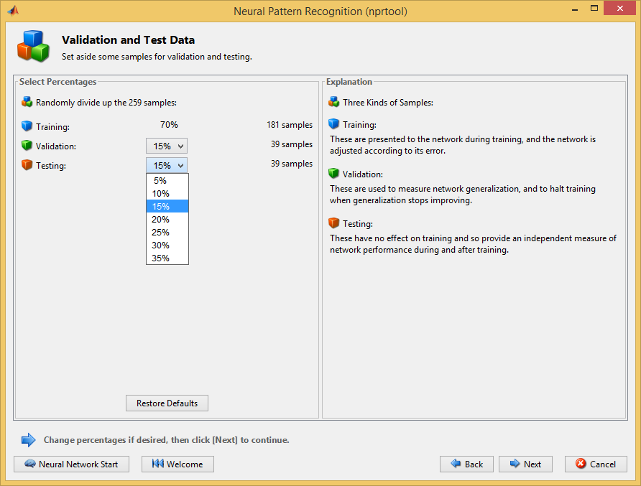
Figure 4.6: Validation and test selection window
After the selection of data as shown in Figure 4.6, training the neural network comes next. The network was trained using scale conjugate gradient (transcg) algorithm, because it helps to automatically makes weight adjustment in order to correct any abnormally during the training.
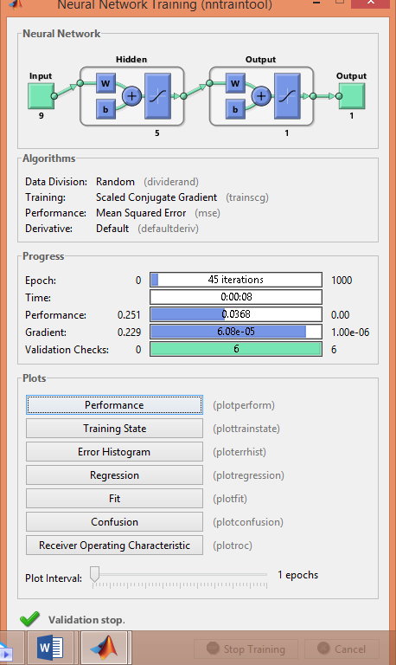
Figure 4.7: neural network structure
As shown in Figure 4.7, it was observed that, the network iterates at 45 epochs which indicates the number of times at which the validation performance was reached, which is at of 8 seconds from the initial time. In addition, the neural network validation checks were 6.08 and the best performance of the network was at 0.0368.
Performance evaluation
Any software application needs to be evaluated in terms of performance and accuracy. Performance evaluation of the system was done using confusion matrix. Confusion matrix shows the accuracy of the training, testing, validation and general accuracy. As shown in Figure 4.8, the green box represents the data that were correctly classified, the red box represents samples that were misclassified and the blue box represents the total percentage of both the correctly classified and the misclassified. The accuracy of the system was 96.1%.
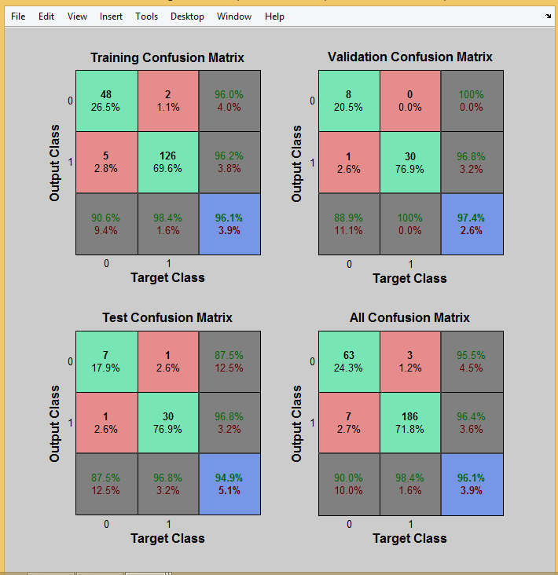
Figure 4.8: Confusion Matrix
As revealed in Figure 4.8, 48 samples where correctly classified, 2 was misclassified as zero, 5 samples were misclassified as one, while 126 samples were classified correctly as one. In terms of validation, 8 samples where correctly classified as zero, 0 sample was misclassified as zero, 1 sample was misclassified as one, while 30 samples were classified correctly as one and the total matrix for the validation was 97.4%. For the testing, 7 samples were correctly classified as zero,1 sample were misclassified as zero, 1 sample were misclassified as one, while 30 samples were classified correctly as one and the total matrix for the testing was 94.9%. From Figure 4.8, 63 samples were correctly classified as zero, 3 samples were misclassified as zero, 7 samples were misclassified as one, 186 samples were classified correctly as one and the total accuracy of the system was 96.1%. This shows relative high accuracy of the system.
4.3 Graphical user interfaces
For effective usage and user friendliness, the system provides graphical user’s interface for easy interaction with the users (PID patients). The first page as the user lunch the application is the index page. This is shown in Figure 4.9. The index page has two buttons; Home and health tips. The home page will guide the user to navigate seamless through the system while the health tips display information about PID.
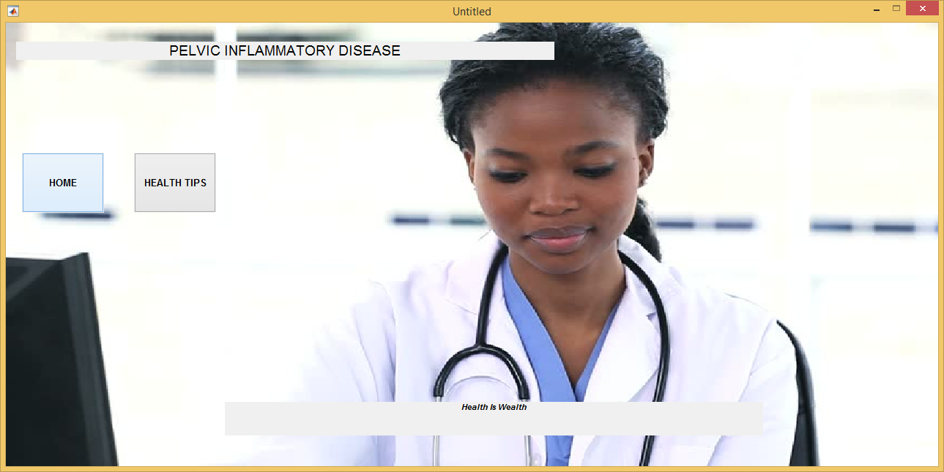
Figure 4.9: The Index Page
When a user clicks on the home page, Figure 10 is shown.

Figure 4.10: Home Page
From Figure 4.10, the user can navigate back to the index page or click on the next button to proceed with the system. Clicking on the next button will take the user to the next page where the selection for the symptoms can be made. The symptoms selection page is as shown in Figure 4.11.

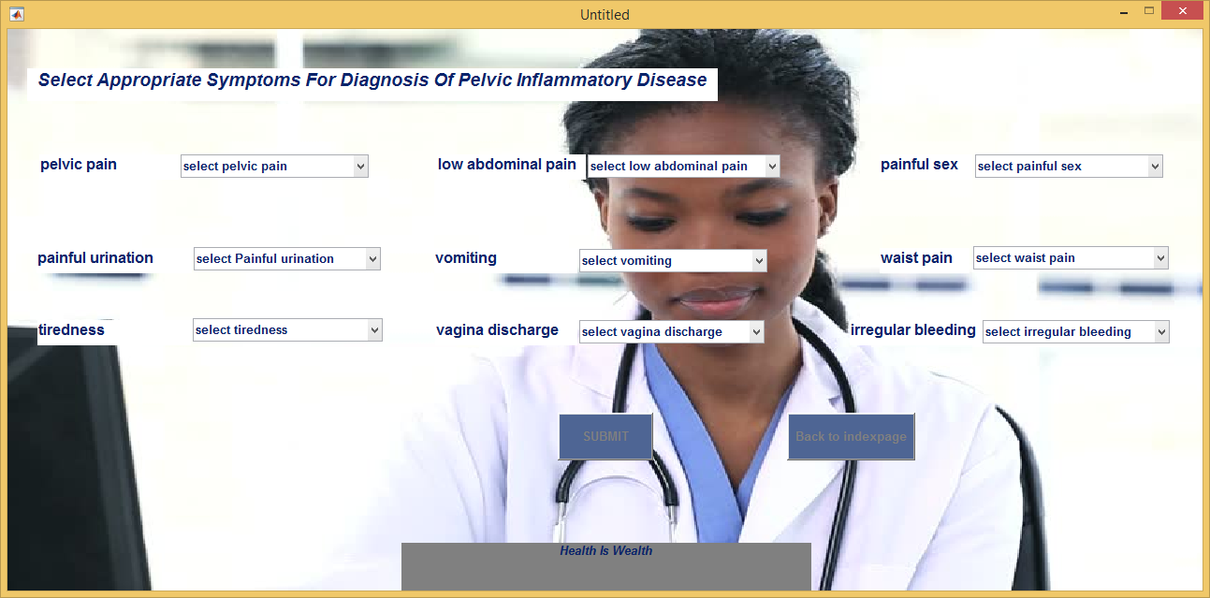
Figure 4.11: Symptoms selection page
From Figure 4.11, the selection for symptoms was made by user as shown in Figure 4.12.

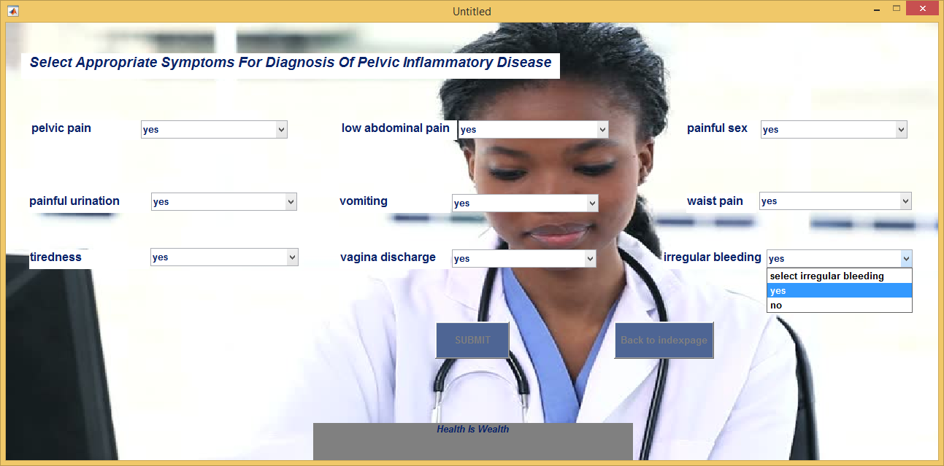

Figure 4.12: Symptoms selection page with particular selected symptoms

After the selection of the different symptoms, the status of the user will be displayed when the user clicks or submit the symptoms to the system. The status of the selection on Figure 4.12 is as shown in Figure 4.13.

Figure 4.13: Patient’s status of symptoms
The selection of the symptoms and the output from the system was compared with the database and the result is in tandem. This shows the relative accuracy of the system.


Figure 4.14: Patient’s data corresponding with output
Another run of the system was carried out by different user and different symptoms, as shown in Figure 4.15.

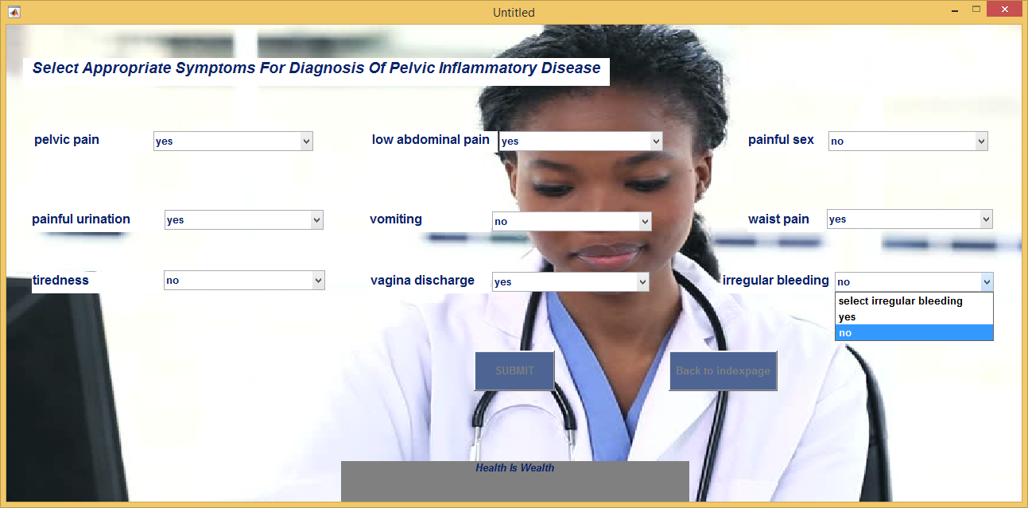

Figure 4.15: Symptoms selection page for negative response
The response from the selection from Figure 4.15 is as shown in Figure 4.16.

Figure 4.16: Patient’s status of symptoms
Furthermore, the system was run (see Figure 4.17) where no symptoms is selected by the user. The response on clicking the submit button is as shown in Figure 4.18. This aspect was implemented to ensure that empty fields are not submitted to the application.
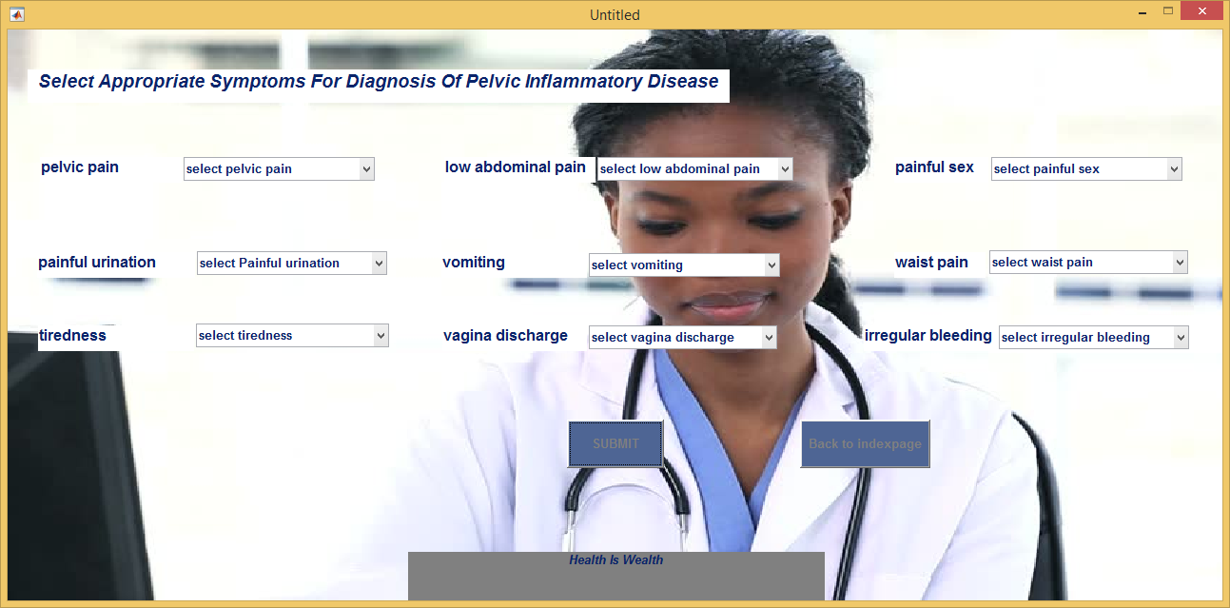
Figure 4.17: Interface with no symptoms selected
If the user selects some of the symptoms on Figure 4.17, the status of the user will be displayed when the user clicks or submit the symptoms to the system. This is as shown in Figure 4.18.
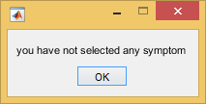
Figure 4.18: No symptoms selected

The system was also run in Figure 4.19 below, where some of the symptoms were selected by the user and other symptoms not selected. The response on clicking the submit button is as shown in Figure 4.20.
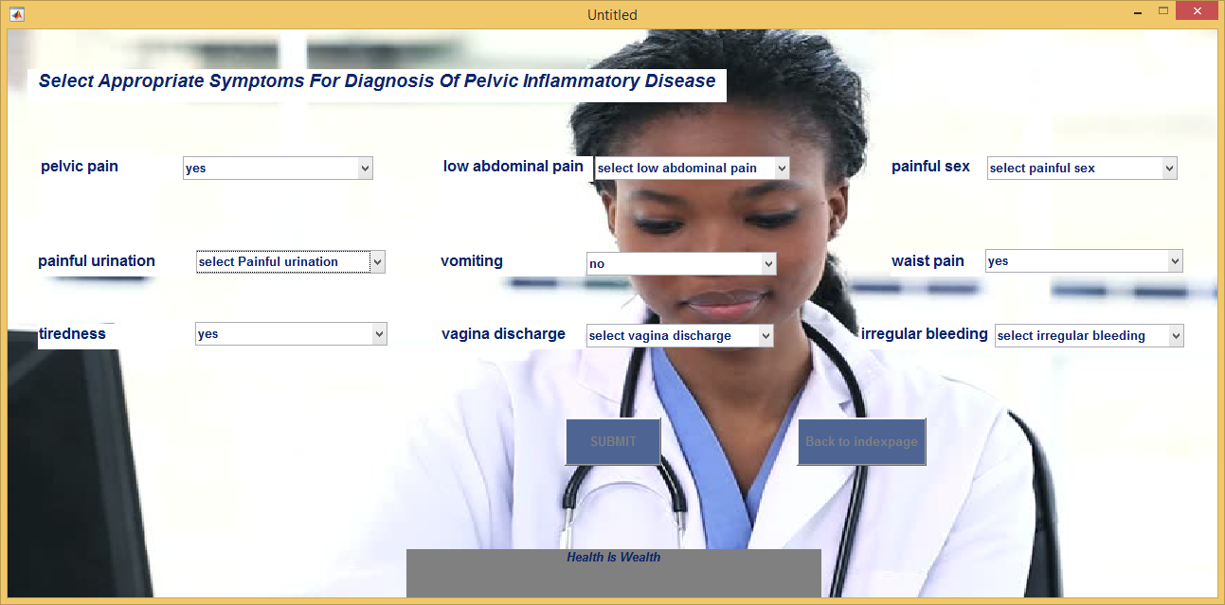
Figure 4.19: Interface with some symptoms selected
With the selection in figure 4.19 above, the system will not be able to diagnose if the patient is positive or negative because the user did not select all the symptoms, it will display the response in figure 4.20 below
Figure 4.20: No symptoms selected

CHAPTER FIVE
SUMMARY, CONCLUSION AND RECOMMENDATION.
5.1 Summary
Pelvic inflammatory disease (PID) is a reproductive health infective disease among minority adolescent girls and young adult women. If PID is not treated, it can cause sterility, ectopic pregnancy, sore development, and prolonged pelvic discomfort. This project designed and developed an ANN based diagnostic system to diagnose PID based on set of available symptoms. The model is created after feasibility analysis of procedural diagnosis by the medical experts. Results of the project evaluation shows high level degree of accuracy of the design system.
5.3 Conclusion
An ANN approach for diagnosis of PID is carried out in this project. Detecting the individual’s PID status early enough is essential for better and effective treatment and by extension cure. Therefore, it is necessary to evolve a means of self or machine detection approach in order to alleviate reality of the PID issues. In this project we have implemented how to effectively make use of ANN in detection and diagnosis of PID status of woman.
Evaluation of the performance and accuracy of the system was performed using confusion matrix. The system was designed with the capability to receive user’s symptoms and notify or show the PID status, based on the assessment or evaluation of the inputted symptoms. The system is user friendly, easy to navigate and highly interactive. So personal evaluation can be done and therefore it will assist those who could not discuss their condition because of stigmatization and by extension assist medical practitioner to reduce fatigue and to adequately plan for the patient.
The network was realised based backward propagation and scale conjugate gradient algorithm using nine PID symptoms. The test and evaluation of the model reveals that the system is able to accurately predict the patients’ status based on the symptoms.
5.3 Recommendation
There is no perfect system and this one is not exempted. Based on the evaluation of the system, the recommendation emanates from the drawback of the system. It is worthy to note that Medical expressions of PID differ among individual, while some show little symptoms, some show none. However, the implementation of the designed system in this project is based on the case of common symptoms. Thus, future research of similar system should consider the case of absence or few symptoms.

REFERENCES
Ahmad, R. W. (2009). Pelvic Inflammatory Disease - An Ovarian Infection. Daily Trust. Retrieved from www.allAfrica.com
Ahmed, F. (2005). Artificial neural networks for diagnosis and survival prediction in colon cancer. Mol Cancer, 4, 29. Retrieved from https://www.ncbi.nlm.nih.gov/pubmed/16083507
Aizenberg, I., Aizenberg, N., Hiltner, J., Moraga, C. & Meyer, E. (2001). Cellular neural networks and computational intelligence in medical image processing. Journal of Image and Vision Computing, 19, 177–183.
Amato, F., López, Peña-Méndez, J., Vaňhara, Hampl & Havel, J. (2013).Artificial neural networks in medical diagnosis. Journal of applied biomedicine, 11(2), 47-58.
Andries, P.E. (2002). Computational Intelligence. National Center for Biotechnology Information, U.S. National Library of Medicine, 6(5), 6–7. Retrieved from www.wileyeurope.com.
Anorlu, R. I. (2008). Cervical cancer: the sub-Saharan African perspective; Reproductive health matter. Elsevier Journal, 16(39), 44. Retrieved from www.rhmjournal.org.uk
Arnold, M. (1996). Non-invasive glucose monitoring. Curr Opin Biotech, 7(1), 46–49. Retrieved from https://www.sciencedirect.com/science/article/pii/S0958166996800930
Banerjee, R. (2003). Predicting mortality in patients with cirrhosis of liver with application of neural network technology. Blackwell Publishing Asia Pvt. Ltd, 18(9), 1054-60.
Baxt, W. G. (1995). Application of Artificial Neural Networks to Clinical Medicine. The Lancet, 346, 1135–1138.
Chen, J.F, Hsieh, H.N. & Hung, D.Q. (2014). Predicting Student Academic Performance: A Comparison of Two Meta-Heuristic Algorithms Inspired by Cuckoo Birds for Training Neural Networks. Algorithms, 7(4), 538–553.
Dayal, S, Singh, A, Chaturvedi, V, Krishna, M. & Gupta, V. (2016). Pattern of pelvic inflammatory disease in women who attended the tertiary care hospital among the rural population of North India. Science, 4, 49.
El-Deredy, W., Ashmore, S. M., Branston, N. M., Darling, J. L., Williams, S. R., & Thomas, D.
G. (1997). Pretreatment prediction of the chemotherapeutic response of human glioma cell
cultures using nuclear magnetic resonance spectroscopy and artificial neural
networks. Cancer Res, 57, 4196–4199.
Fernández, E. A., Valtuille, R., Presedo, J. R. & Willshaw, P. (2005). Comparison of Standard and Artificial Neural Network Estimators of Hemodialysis Adequacy. International journal of Scientific Publication., 29(2), 159–165.
Furness, P.N., Levesley, J., Luo, Z., Taub, N. Kazi, J. I., Bates, W. D. & Nicholson, M. L. (1999). A neural network approach to the biopsy diagnosis of early acute renal transplant rejection Histopathology. International Center for Artificial Organs and Transplantation., 35, 461–467.
Gerberding, J. L. (2004). Women and Infectious Diseases. National Center for Biotechnology Information, U.S. National Library of Medicine, 10(11), 1965–1967. Retrieved from https://www.ncbi.nlm.nih.gov/pmc/articles/PMC3329060
Gjertsson, P., Lomsky, M., Richter, J., Ohlsson, M., Tout, D., Aswegen V., A., Edenbrandt, L. (2006). The added value of ECG-gating for the diagnosis of myocardial infarction using myocardial perfusion scintigraphy and artificial neural networks. Clinical Physiology and Functional Imaging, 26(5), 301-304. Retrieved from http://www.academia.edu/13973482
Goyal, M., Hersh, A., Luan, X., Localio, R., Trent, M. & Zaoutis, T. (2013). National Trends in Pelvic Inflammatory Disease among Adolescents in the Emergency Department. J Adolesc Health, 52(2), 249–52. https://doi.org/10.1016/j.jadohealth.2013.03.016
Health Special Report. (2015). Shortage of medical personnel: Tougher times ahead for Nigerians. Vanguard News. Retrieved from vanguardngr.com
Jefferson, M.F., Pendleton, N., Lucas, S.B. & Horan, M.A (1997). Comparison of a genetic algorithm neural network with logistic regression for predicting outcome after surgery for patients with nonsmall cell lung carcinoma. Cancer, 79(7), 1338–1342. Retrieved from http://europepmc.org/abstract/med/9083155
Kajan, S., Higuera V., Pernecký, D. & Goga, J.V. (2015). Application of Neural Network in Medical Diagnostics, Healthline, 2, 1–2.
Leon, B. S., Alanis, A. Y., Sanchez, E. N., Ornelas-Tellez, F., & Ruiz-Velazquez, E. (2012). Inverse optimal neural control of blood glucose level for type 1 diabetes mellitus patients. Journal of the Franklin Institute, 20, 1851–1870. Retrieved from https://doi.org/10.1016/j.jfranklin.2012.02.011
Mahesh, C. & Manjula, B. (2013). Diagnosing Hepatitis B Using Artificial Neural Network Based Expert System, International Journal of Engineering and Innovative Technology. Life Science Journal, 3(6), 139.
Mattias, O. (2006). The added value of ECG-gating for the diagnosis of myocardial infarction using myocardial perfusion scintigraphy and artificial neural networks, Clinical Physiological Functional Imaging, 26, 301–304.
Miller, A. (1993). The Application of Neural Networks to Imaging and Signal Processing in Astronomy and Medicine. Ph.D. Thesis, Faculty of Science, Department of Physics, University of Southampton, 12-15.
Nazeran, H., & Behbehani, K. (2001). Neural networks in processing and analysis of biomedical
signals, In M. Akay (Ed.), Nonlinear biomedical signal processing: Fuzzy logic, neural
networks and new algorithms. 69–97.
Negnevitsky, M. (2005). Artificial Intelligence: a guide to intelligent systems. Pearson Education Limited, 132, 435. Retrieved from https://www.abebooks.com
Ohno-Machado, L. (1996). Medical Applications of Artificial Neural Networks: Connectionist Models of Survival. CiteSeerX, (45), 100–256.
Özbay, A. Y. (2009). A new approach to detection of ECG arrhythmias: Complex discrete wavelet transform based complex valued artificial neural network. J Med Syst.33, 435–445.
Rumelhart, D., Hinton, G. & Williams, R. (1986). Learning Representations by Backpropagating Errors. Nature, 323, 533–536.
Schindlbeck, C, Dziura, D. & Mylonas, I. (2014). Diagnosis of pelvic inflammatory disease (PID): Intra-operative finding and comparison of vaginal and intra-abdominal cultures. International Journal of Arch Gynecology Obstet, 289, 1263–9.
Shanthi, D., Sahoo, D. & Saravanan, N. (2010). Designing an Artificial Neural Network Model for the Prediction of Thrombo-embolic Stroke. International Journals of Biometric and Bioinformatics (IJBB), 3(1), 10–18.
Shepherd, S. M & Editor, C. (2017). Pelvic Inflammatory Disease. Medscape, no pp. Retrieved from emedicine.medscape.com/article/256448-workup
Shortliffe, E.H; Perreault L.E; Fagan L.M & Wiederhold G. (1990). Hospital Information Systems. Medical Informatics: Computer Applications in Health Care. Addison-wesley,Reading, 219-243.
Simon, D. (2012). Introduction to Neural Networks. Brainwave, 5(4), 1–4. Retrieved from http://staff.itee.uq.edu.au/janetw/cmc/chapters/Introduction/
Singh, R. P., Rawat, V., Pawar, M. & Mishra, R. K. (2012). Design of an optimal multi-layer neural network for eigenfaces based face recognition. Recent Research in Science and Technology, 4(1), 24–32.
Sivanandam, S.N., Sumathi, S. & Deepa, S. N. (2006). The Application of Neural Networks to Imaging and Signal Processing in Astronomy and Medicine Using MATLAB 6.0. McGraw-Hill Education, 3, 1–4.
Tanzila, S., Saleh, A. & Amjad, R. (2012). Expert System for Offline Clinical Guidelines and Treatment. Life Science Journal, 393, 2639–2658.
Thakur, A., Mishra, V. & J. S. (2011). Feed forward artificial neural network: tool for early detection of ovarian cancer. Sci Pharm, 79, 493–505. Retrieved from https://www.ncbi.nlm.nih.gov/pubmed/21886899
Trent, M., Ellen, J.M. & Frick, K.D. (2011). Estimating the Direct Costs of Pelvic Inflammatory Disease in Adolescents: A Within-System Analysis. Sex Transm Dis, 38(4), 326–8.
Uguz, H. (2012). A biomedical system based on artificial neural network and principal component analysis for diagnosis of the heart valve diseases. Journal of applied biomedicine, 36, 61–72. Retrieved from https://www.ncbi.nlm.nih.gov/pubmed/20703748
Weinstein, J., Kohn, K., Grever, M., Viswanadhan, V.N., Rubinstein, L.V., Monks, A.P., Scudiero, D.A., Welch, L., Koutsoukos, A.D. & Chiausa, A.J. (1992). Neural Computing in Cancer Drug Development: Predicting Mechanism of Action. Science, 258, 447–451.Retrieved from https://www.ncbi.nlm.nih.gov/pubmed/1411538
Westrom, L. (1995). Effect of pelvic inflammatory disease on fertility. Venereology, 8(4), 219–222. Retrieved from https://www.ncbi.nlm.nih.gov/pubmed/12291198
World Health Organization. (2001). Global prevalence and incidence of selected curable sexually transmitted infections: overview and estimates, 40–47.

APPENDIX
function varargout = diagnosis(varargin)
gui_Singleton = 1;
gui_State = struct('gui_Name', mfilename, ...
'gui_Singleton', gui_Singleton, ...
'gui_OpeningFcn', @diagnosis_OpeningFcn, ...
'gui_OutputFcn', @diagnosis_OutputFcn, ...
'gui_LayoutFcn', [] , ...
'gui_Callback', []);
if nargin && ischar(varargin{1})
gui_State.gui_Callback = str2func(varargin{1});
end

if nargout
[varargout{1:nargout}] = gui_mainfcn(gui_State, varargin{:});
else
gui_mainfcn(gui_State, varargin{:});
end
function diagnosis_OpeningFcn(hObject, eventdata, handles, varargin)
% Choose default command line output for diagnosis
handles.output = hObject;
%create an axes that spans the whole gui
bg = imgread('h.jpg'); imagesc(bg);
%prevent plotting over the background and turn the axis off
set(ah,'handlevisibility','off','visible','on')
%making sure the background is behind all the other uicontrols
uistack(ah);

% Update handles structure
guidata(hObject, handles);
if strcmp(get(hObject,'Visible'),'on')
plot(rand(5));
end

% --- Outputs from this function are returned to the command line.
function varargout = diagnosis_OutputFcn(hObject, eventdata, handles)
% Get default command line output from handles structure
varargout{1} = handles.output;

% --- Executes on button press in pushbutton1.
function submit_Callback(hObject, eventdata, handles)
% hObject handle to submit (see GCBO)

if(get(handles.pelvicpain,'value')==1)
msgbox('you have not selected any symptom')
elseif(get(handles.pelvicpain,'value')==2)
a=1;
elseif(get(handles.pelvicpain,'value')==3)
a=0;
end
if(get(handles.lowabdominalpain,'value')==1)
msgbox('you have not selected any symptom')
elseif(get(handles.lowabdominalpain,'value')==2)
b=1;
elseif(get(handles.lowabdominalpain,'value')==3)
b=0;
end
if(get(handles.painfulsex,'value')==1)
msgbox('you have not selected any symptom')
elseif(get(handles.painfulsex,'value')==2)
c=1;
elseif(get(handles.painfulsex,'value')==3)
c=0;
end
if(get(handles.painfulurination,'value')==1)
msgbox('you have not selected any symptom')
elseif(get(handles.painfulurination,'value')==2)
d=1;
elseif(get(handles.painfulurination,'value')==3)
d=0;
end
if(get(handles.vomiting,'value')==1)
msgbox('you have not selected any symptom')
elseif(get(handles.vomiting,'value')==2)
e=1;
elseif(get(handles.vomiting,'value')==3)
e=0;
end
if(get(handles.waistpain,'value')==1)
msgbox('you have not selected any symptom')
elseif(get(handles.waistpain,'value')==2)
f=1;
elseif(get(handles.waistpain,'value')==3)
f=0;
end
if(get(handles.tiredness,'value')==1)
msgbox('you have not selected any symptom')
elseif(get(handles.tiredness,'value')==2)
g=1;
elseif(get(handles.tiredness,'value')==3)
g=0;
end
if(get(handles.vaginadischarge,'value')==1)
msgbox('you have not selected any symptom')
elseif(get(handles.vaginadischarge,'value')==2)
h=1;
elseif(get(handles.vaginadischarge,'value')==3)
h=0;
end
if(get(handles.irregularbleeding,'value')==1)
msgbox('you have not selected any symptom')
elseif(get(handles.irregularbleeding,'value')==2)
i=1;
elseif(get(handles.irregularbleeding,'value')==3)
i=0;
end

z=[a,b,c,d,e,f,g,h,i]
load net
out=round((z));
if out==1
msgbox('you are positive')
else
msgbox('you are negative')
end
% --- Executes on button press in backtoindex.
function backtoindex_Callback(hObject, eventdata, handles)
% hObject handle to backtoindex (see GCBO)

